Skype Quick Start Guide

Version 1.0 ● 10 June 2019.



Skype – URL: <https://www.skype.com/en>

By: Anthia Pun

For: TCN700- Technical Writing 1

© 2019 Skype or a Skype affiliate company. All rights reserved.

Skype 1234 Provincial Street

123-4567 https://www.skype.com/en

**Trademarks**

Skype are registered trademarks of Skype. All other trademarks or registered trademarks are the property of their respective owners.

**Disclaimer**

The information provided in this document is provided "as is" without warranty of any kind. Skype disclaims all warranties, either express or implied, including the warranties of merchantability and fitness for a particular purpose. In no event shall Skype be liable for any damages whatsoever including direct, indirect, incidental, consequential, loss of business profits or special damages, even if Skype or its suppliers have been advised of the possibility of such damages.

**Document Lifetime**

Skype may occasionally update online documentation between releases of the related software. Consequently, if this document was not downloaded recently, it may not contain the most up-to-date information. Please refer to <https://www.skype.com/en> for the most current information.

From the Web site, you may also download and refresh this document if it has been updated, as indicated by a change in this date: 18/06/2019.

**Where to get help**

Skype support, product, and licensing information can be obtained as follows.

**Product** **information** — Documentation, release notes, software updates, and information about Skype products, licensing, and service, are at Skype website at:

https://www.skype.com/en

**Technical** **support** — Go to <https://www.skype.com/en> and select Support. On the Support page, you will see several options, including one for making a service request. Note that to open a service request, you must have a valid support agreement.

**Your comments**

Your suggestions will help us continue to improve the accuracy, organization, and overall quality of the user publications. Please send your opinion of this document to:

Documentation@Skype.com

If you have issues, comments, or questions about specific information or procedures, please include the title and, if available, the part number, the revision, the page numbers, and any other details that will help us locate the subject that you are addressing.

Preface

**Style Conventions**

The following style conventions are used in this document:

**Bold**

Names of commands, options, programs, processes, services, and utilities

Names of interface elements (such windows, dialog boxes, buttons, fields, and menus)

Interface elements the user selects, clicks, presses, or types

*Italic*

Publication titles referenced in text

Emphasis (for example a new term)

Variables

Courier

System output, such as an error message or script

URLs, complete paths, filenames, prompts, and syntax

*Courier italic*

Variables on command line

User input variables

< > Angle brackets enclose parameter or variable values supplied by the user

[ ] Square brackets enclose optional values

| Vertical bar indicates alternate selections - the bar means “or”

{ } Braces indicate content that you must specify (that is, x or y or z)

Table of Contents

**1 Introduction 5**

1.1 New Features and benefits of Skype 1.0 5

**2 Getting Started 6**

2.1 Finding Skype on the Internet 6

2.2 Downloading Skype version 1.0 8

2.3 Setting-up a Skype Account 8

2.4 Testing the Microphone Sound to Ensure that it Works 11

2.5 Using the Video Call Feature to Contact One Person 13

2.6 Ending the Video Call. 14

**3 System Requirements 15**

3.1 Minimum Server Requirements 15

3.2 Minimum Workstation Requirements 15

**4 Additional Tools and Tips 16**

4.1 Adding a Profile Picture to your Skype Account 16

4.2 Adding Contacts to your Skype Contacts List 18

4.3 Setting up a three-way call and hanging-up 19

**5 Related Documentation 20**

5.1 obtaining documentation 20

5.1.1 World Wide Web 20

5.1.2 Product Documentation CD-ROM 20

5.1.3 Ordering Documentation 21

5.1.4 Documentation Feedback 21

# 

# Introduction

Skype 1.0 is a video and voice calling software that allows users to communicate with loved ones living abroad and is accessible with basic internet connection. For the purposes of this Skype Quick Start Guide, we will be focusing on how to download and use Skype software on a laptop or desktop with an already-installed webcam and microphone. The main features and components are outlined in the following sections.

## New Features and benefits of Skype 1.0

**Product Description:**

Release 1.0 of Skype provides a flexible communications system and offers a variety of communications tools. Video calling and voice calling are two examples of how Skype facilitates communication over the internet to better-connect individuals with their loved ones who live abroad. Instant messaging over Skype is also possible, similar to texting back-and-forth on a Smartphone. Listed below are some of Skype’s main features and benefits.

**The product Skype 1.0 offers the following new features and benefits:**

| Feature: | Benefit: |
| --- | --- |
| Skype Contacts List | Create, search for, add and delete Skype contacts while organizing contacts into different sub-sections within your overall Contacts List. |
| Skype to Skype Voice Call | Make a voice-only call (microphone enabled) connecting you and a fellow Skype contact to facilitate a private conversation over the internet. |
| Skype to Skype Video Call (one-on-one) | Activates your built-in Laptop or Desktop webcam and microphone and that of your fellow Skype contact to facilitate a private conversation over the internet. |
| Skype to Skype Video Group Call | Get a group of friends or family that all use Skype on their Laptops or Desktops to participate in a video call at the same time. |
| Video Messaging | Allows you to record and send a video message to another Skype contact that they can see, hear and feel. |
| Instant Messaging | Allows you to type messages and receive typed messages from your Skype contact of choice in a conversation box. |
| Send Texts (SMS) | You can send instant messages through Skype and onto your contact’s mobile phone through your Laptop or Desktop. |
| Skype Voicemail System | Skype enables you to create a voicemail box, record a personalized voicemail greeting and listen to voice-recorded messages left by other Skype contacts. Never miss a message or opportunity to get back to someone important. |
| Send and Share Files | Send files, photos and videos of any size over Skype Voice and Video Calling. Simply drop or add the file to your current Skype chat. |
| Skype Translator | Translate voice calls, video calls and instant messages to facilitate a conversation with a Skype contact that speaks another language. |

# Getting Started

This chapter describes the typical default configuration of the [system]. Below are six tasks every beginner should go through to start using Skype 1.0. The following sections are contained in this chapter for your benefit:

* Finding Skype on the Internet
* Downloading Skype version 1.0
* Setting-up a Skype account
* Testing the microphone sound to ensure it works
* Using the Video Call feature to contact one person
* Ending a Video Call

## Finding Skype on the Internet

You can find Skype software to download by using an internet search engine. Google, Mozilla Fox, Opera, Safari and Internet Explorer will all yield the same results.

**Step 1:** Open a web browser (already installed in your Laptop or Desktop) and in the search engine bar, type in **Skype**.

**Step 2:** Press **Enter**.

**Step 3:** If using the Google search engine bar, the following results screen is displayed:

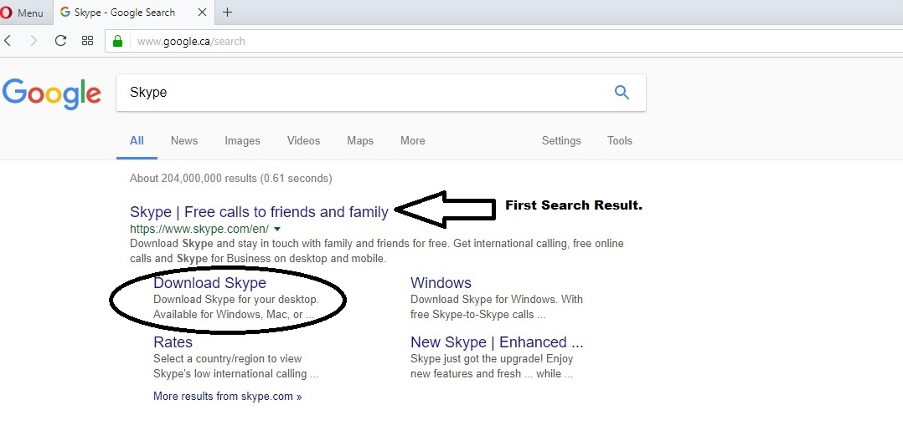

**Step 4:** Click on the **Download Skype** link. The following startup screen is displayed:

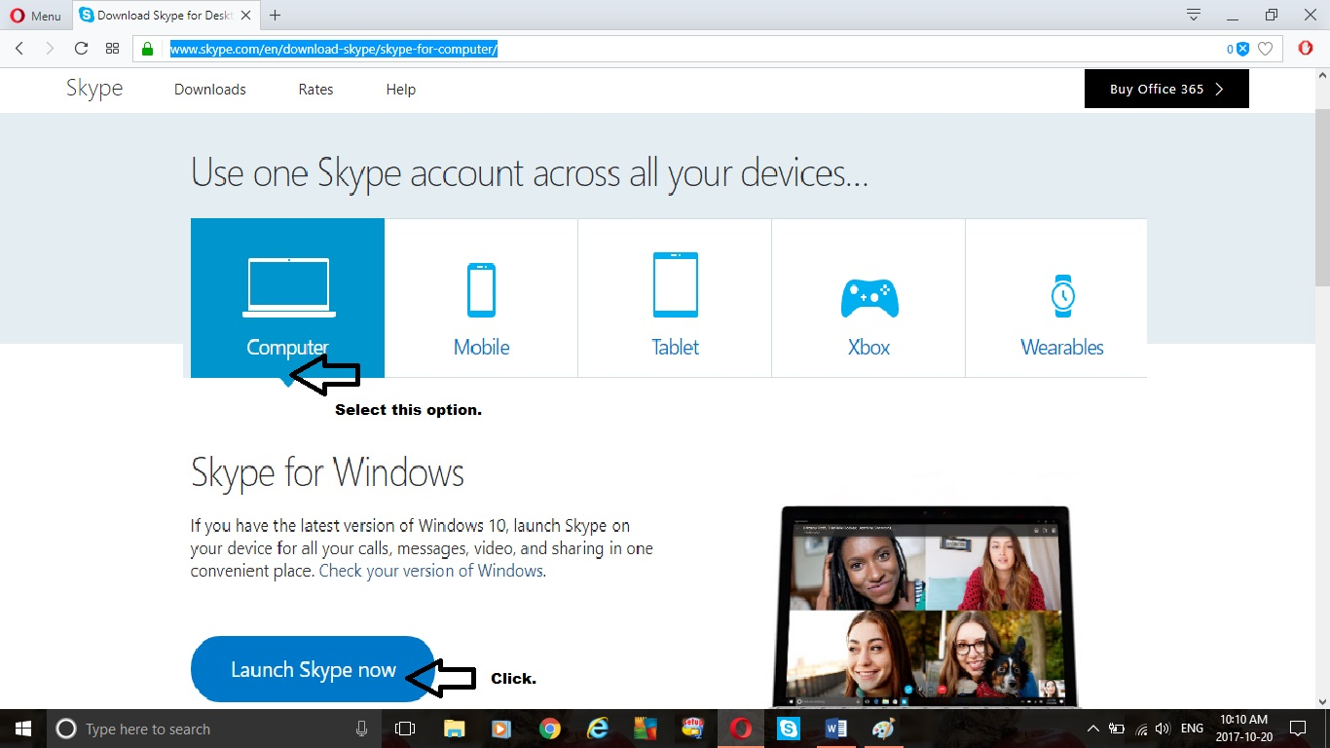

## Downloading Skype version 1.0

Continuing from the last screen shot, follow these instructions to download Skype:

**Step 1:** Mouse Click to select the **Computer** option.

**Step 2:** Mouse Click on the **Launch Skype Now** button.

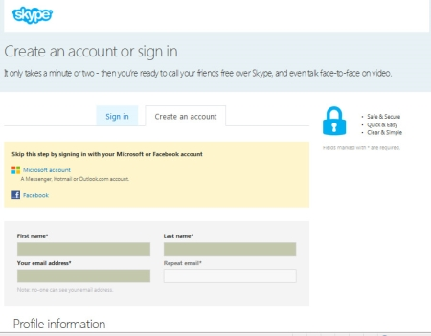**Step 3:** A **Launch Skype** Prompt window pops-up that reads “Do you want to launch Skype to handle this link from ‘www.skype.com’?” Click on the **Allow** button.

The following startup Skype window is displayed:

## Setting-up a Skype Account

Here is how to set-up a Skype account:

**Step 1:** Follow the prompts and type-in values to fill-in your **First Name**, **Last Name**, your **email address** and **repeated email** address.

**Step 2:** Scroll down the page to view the **Profile Information**, as follows:

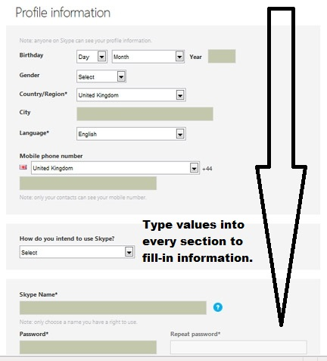

**Step 3:** Fill-in your Profile Information by typing-in values for each section.

**Sections to be filled-in:**  
1.) Birthday (Day, Month and Year)  
2.) Gender  
3.) Country/Region  
4.) City  
5.) Language  
6.) Mobile Phone Number  
7.) How do you intend to use Skype?  
8.) Skype Name  
9.) Password  
10.) Repeat Password

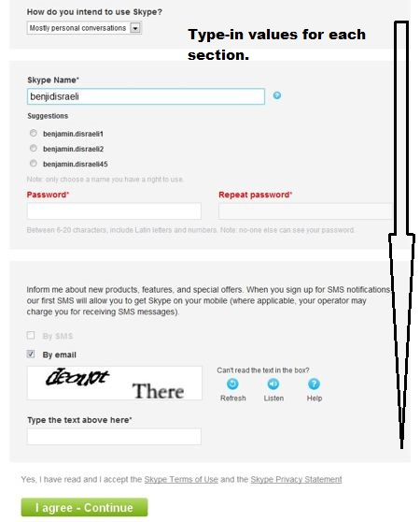**Step 4:** Scroll down the page and fill-in the rest of the Profile Information by typing-in values for every section:

**Sections to be filled-in:**1.) Skype Name (or variation options if you Skype Name is taken by another Skype user)  
2.) Password  
3.) Repeat Password  
4.) Security Code sent to email

**Step 5:** Click on the **“I agree-Continue”** button to move onto the next page.

The following Skype screen displays:

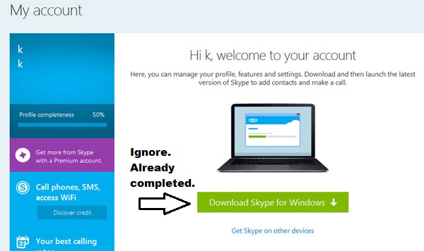

You have successfully created an active Skype account.

## Testing the Microphone Sound to Ensure that it Works

Make a free test call in Skype. The test call prompts you to record a message, and then plays it back for you to determine if there are any audio issues with your built-in microphone that comes with your Laptop or Desktop.

**How it works:**

1. To check that your sound and microphone are working properly in Skype, you can make a test call to the assistant **Echo**.
2. She will prompt you to record a message, and then play it back for you – so you’ll know right away if your sound is working.

**Step 1:** On the Skype main window, search for the **Echo/Sound Test Service contact**.

Go to **Tools** 🡪 **Options** as illustrated:

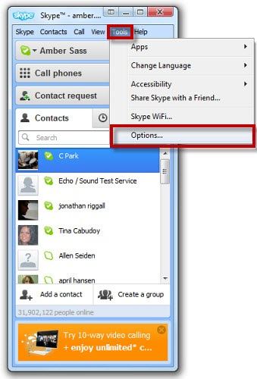

**Step 2:** Under the Audio Settings tab, select “Make a free call,” as illustrated:

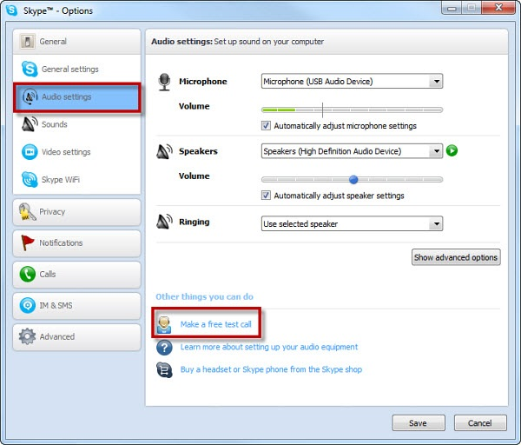

**Step 3:** Call **Echo** and follow her instructions. If you heard **Echo’s** voice and heard your **recorded message**, then your sound and microphone are working just fine, and you are good to go.

**Step 4:** Press the Red Phone icon to end test call with Echo and return to main Skype window.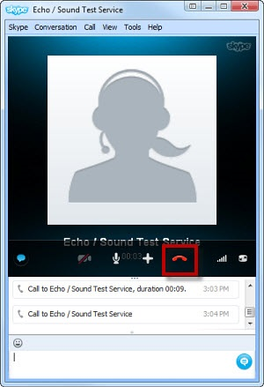

## Using the Video Call Feature to Contact One Person

Here is how to use the video call feature in Skype to contact one other person:

**Step 1:** Under the **Contacts** tab in the left margin of the Skype window, click on the **contact** you would like to video call:

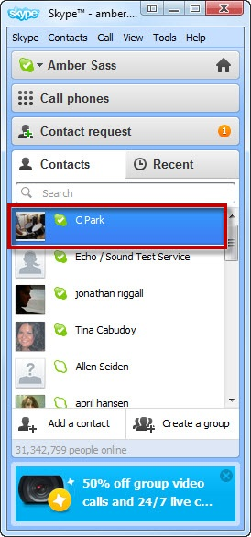

**Step 2:** Click on the **video camera icon** to instigate a video call:

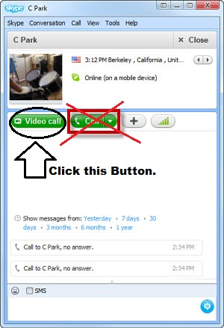

**Step 3:** Video call commences where you and the person of contact both have visuals- webcams are activated:

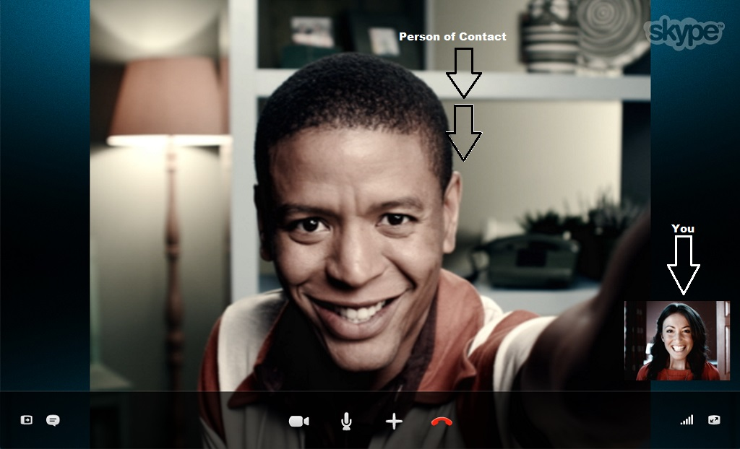

## **Ending the Video Call.**

**Step 1:** Click on the **red telephone icon** to end the video call conversation. You are automatically returned to your main Skype window.

The following picture illustrates how to end a video call:

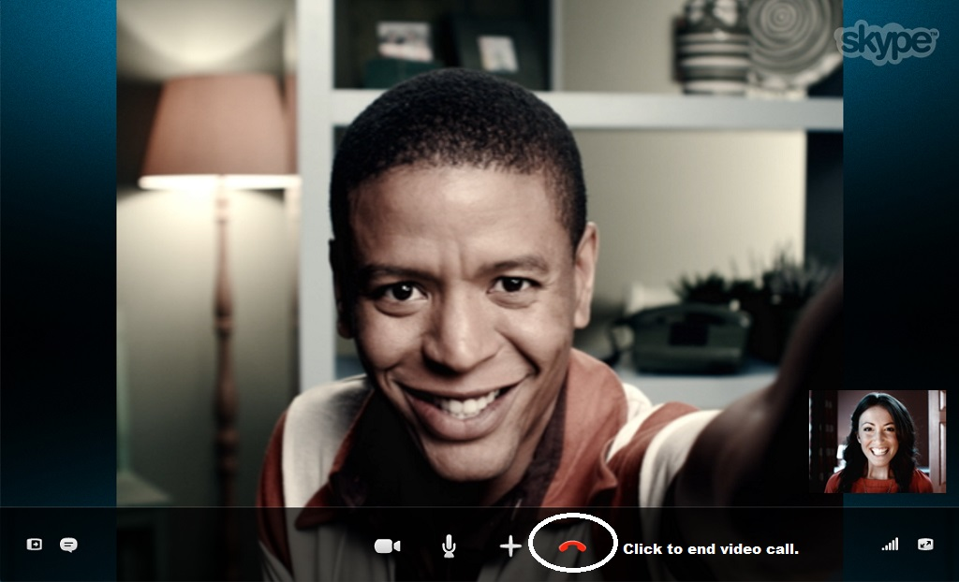

# System Requirements

## Minimum Server Requirements for Skype 1.0

**The following are the minimum server requirements for using Skype 1.0:**

* Dual-processor computer with 1 gigabyte (GB) of available memory (2 GB is recommended) and a clock speed of 2.5 gigahertz (GHz)
* One of the following operating systems:
  + Microsoft Windows Server® 2010 with Service Pack 1 (SP1)
  + Windows Server 2009 with SP1, Enterprise Edition
  + Windows Server 2008 with SP1, Datacenter Edition
  + Windows Server 2007 with SP1, Web Edition
* Internet Information Services (IIS) in IIS 6.0 worker process isolation mode
* NTFS file system
* Microsoft Windows SharePoint Services version 7
* 1 Gigabyte (GB) of available disk space
* Intel processor or equivalent
* MAPI client, such as Microsoft Outlook

## Minimum Workstation Requirements

**The following are the minimum requirements for using Skype 1.0 to make video and voice calls:**

* One of the following operating systems on a Laptop or Desktop:
  + Microsoft Windows Server® 2010 with Service Pack 1 (SP1)
  + Windows Server 2009 with SP1, Enterprise Edition
  + Windows Server 2008 with SP1, Datacenter Edition
  + Windows Server 2007 with SP1, Web Edition
* 1 GB of available memory
* 800 MB of available disk space
* Intel processor or equivalent
* Built-in Microphone for Laptop or Desktop
* Built-in Webcam for Laptop or Desktop
* Strong Internet Connection
* Web Browser (Opera, Google Chrome, Mozilla Fox, Internet Explorer, Safari)
* Mouse
* Keyboard

# Additional Tools and Tips

## Adding a Profile Picture to your Skype Account

**How to Add a Profile Picture to your Skype Account:**

**Step 1:** On the main Skype window, click your Skype Profile Picture in the top left corner, as illustrated:

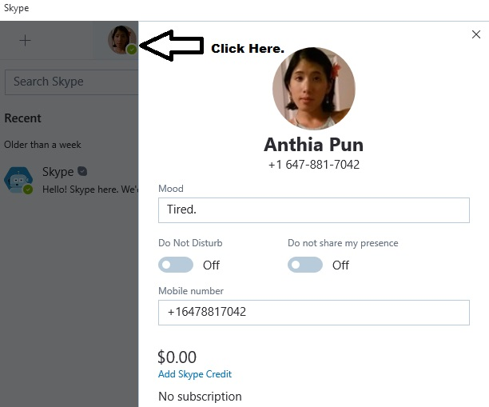

**Step 2:** Now, double-click on the bigger Skype Profile Picture in the middle of the screen to initiate your Webcam:

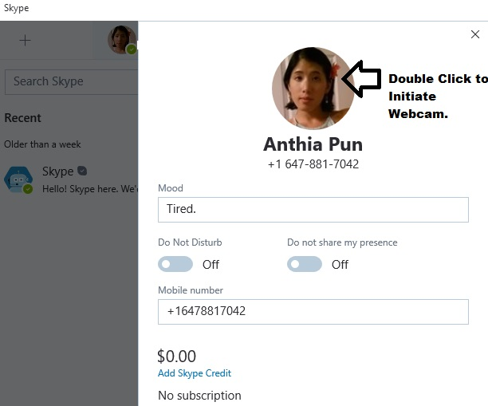

**Step 3:** Click the **Webcam Icon** to take the picture.

**Step 4:** Click the **Save** button to have the image automatically applied as your new Profile Picture:

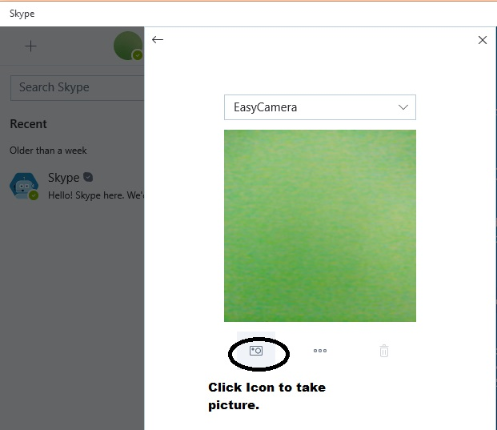

## Adding Contacts to your Skype Contacts List

**How to Add Contacts to your Skype Contacts List:**

**Step 1:** On the Skype main window, click the **Contacts tab**.

**Step 2:** Click on **Add a Contact** > **Search Skype Directory**.

**Step 3:** Type in the contact’s full name in the search bar > Click **Search Skype**.

**Step 4:**

A.) Scroll through the list of results and find the right contact> Click on their Profile Picture to highlight the text > Click **Add to Contacts**.

B.) Backspace the contact name in the search bar and type in a different contact name. Repeat instructions.

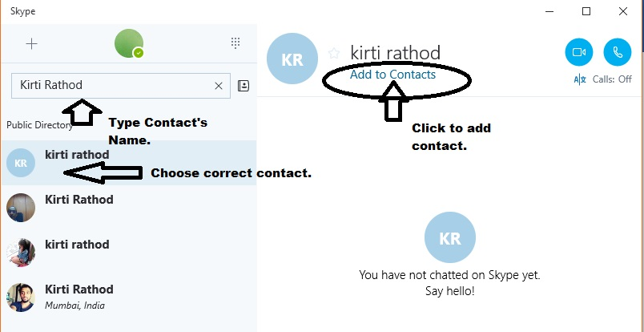

**OR:** If you know the contact’s name and phone number, click on the **Contacts** tab on the main Skype window.

**Step 1:** Click on **Add a Contact** > **Save a number.**

**Step 2:** Type in the contact’s Name, Number and select the type (source) of phone number presented > Click **Add Number** button.

**Step 3:** Repeat instructions for every contact.

***Special Note: A special note will be sent to the contact you are trying to add to your Contacts List. Once they confirm, you two will be connected on Skype and appear on one another’s Contacts List.***

## Setting-up a Three-Way Video Call and Hanging-Up

Follow these instructions to set-up a three-way video call and hang-up on the call:

**Step 1:** Start by clicking on one contact you would like to video-call.

**Step 2:** Now, click the **new icon button** to add participants:

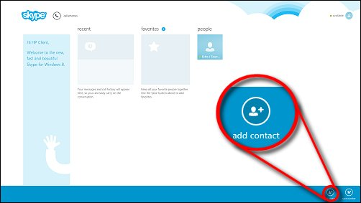

**Step 3:** Select other people in your contact list to add to the group video call.

**Step 4:** Press the **Video camera button** to initiate a group video call:



**Step 5:** Press the **Red phone icon** to end the video call:



# Related Documentation

|  |  |  |  |  |
| --- | --- | --- | --- | --- |
| # | Document Title: | Version: | Location: | Author: |
| 1 | Skype User and Task Analysis | 1.0 | URL:  https://www.wixsite.com/anthiapun/apun0808/myportfolio | Anthia Pun |
| 2 | Skype User Guide Documentation Plan | 1.0 | URL:  https://www.wixsite.com/anthiapun/apun0808/myportfolio | Anthia Pun |
| 3 | Skype Online Help Website | 1.0 | URL:  https://support.skype.com/en/skype/windows-desktop/ | Anthia Pun |

## Obtaining Documentation

**The following sections provide sources for obtaining documentation from [Skype].**

### World Wide Web

You can access the most current [Skype] documentation on the World Wide Web at the following site: [**https://support.skype.com/en/skype/windows-desktop/**](https://support.skype.com/en/skype/windows-desktop/)

### Product Documentation CD-ROM

Technical documentation is available in a CD-ROM package that ships with your product. The Product Documentation CD-ROM is updated as required.

To order additional copies of the Product Documentation CD-ROM, contact your local sales representative or call customer service. The CD-ROM package is available as a single package or as an annual subscription.

You can also access [Skype] documentation at URL:

<https://support.skype.com/en/skype/windows-desktop/>

### Ordering Documentation

[Skype] documentation is available in the following ways:

Registered Customers can order documentation, including the Product CD-ROM from <https://www.skype.com/en/>

### Documentation Feedback

If you are reading [Skype] product documentation on the Internet, you can submit technical comments on the support website.

You can e-mail your comments to [concerns@support.skype.com/en/skype].

To submit your comments by mail, use the response card behind the front cover of your document, or write to the following address:

**Attn: Publications Manager (Anthia Pun)**

**1234 Provincial Street, Toronto, Ontario, Canada**

**L4J9K0**

We appreciate your comments.

# Works Cited

“How Do I Create a New Account for Skype?” *How Do I Create a New Account for Skype*, Skype, 14 Jan. 2017, support.skype.com/en/faq/FA12413/how-do-i-create-a-new-account-for-skype.

“How Do I Test My Sound Is Working in Skype (Make an Echo Test Call)?” *How Do I Test My Sound Is Working in Skype (Make an Echo Test Call)?*, Skype, 2017, support.skype.com/en/faq/FA265/how-do-i-test-my-sound-is-working-in-skype-make-an-echo-test-call.

“How to Download Skype.” *How to Download Skype: Step-By-Step Guide (With Pictures)*, DigitalUnite, 8 Mar. 2017, [www.digitalunite.com/guides/email-skype/skype/how-download-skype](http://www.digitalunite.com/guides/email-skype/skype/how-download-skype).

“Video-Video Calling.” *Help for Skype: User Guides, FAQs, Customer Support*, Skype, 12 Feb. 2017, support.skype.com/en/skype/windows-desktop/video/video-calling/.