Implementing Agile Project Management for your Documentation Projects

Understanding Agile Project Management and the SCRUM Method for Efficient and Flawless Documentation/Projects

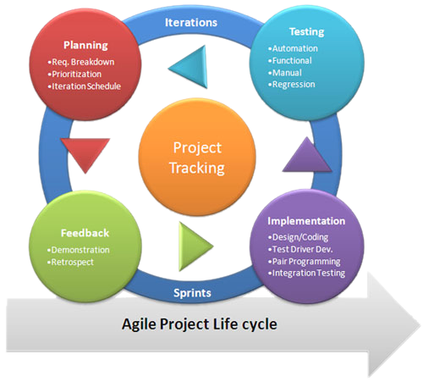

**By: Anthia Pun, Kirti Rathod and Asha Hassan**

# Synopsis:

This Handbook is the perfect guide for any technical communicator looking for efficient ways to plan projects and create flawless documentation and plan projects.

Agile Project Management is the process of continuously working on and improving a project during the creation process.

By the end of this handbook, you will have a clear understanding of the Agile Method, how to implement it in your projects through understanding of the Agile Life Cycle and SCRUM method.

# Procedure and Scope:

This is an explanation of how to implement the Agile Project Management Life Cycle to help you organize your projects, workflow and teamwork. We will provide examples of how we utilized Agile Life Cycle principles to help us create a chapter on Agile Project Management in the context of the *How-To Handbook for Tech Comm’ers* assignment.

# Scope Exclusions:

Other methods of Agile Project Management are not covered in this chapter of the *How-To Handbook for Tech Comm’ers*. Please see page 4 for a list of external links that provide supplementary reading and understanding of Agile Project Management and its most popular methods (e.g. SCRUM method, Lean IT, Dynamic System Development Model). Also, a comparison to the Waterfall Project Management model is not included.

# Audience Skills and Background Needed:

* Targeted reader audience is Technical Communications students enrolled in Seneca College’s Tech Comm. Program
* Readers are assumed to have strong verbal and written communication skills and be proficient in the English language
* Critical thinking skills are required to identify examples of Agile Project Management that exist in the approach Seneca Tech Comm’s Program takes to assigning projects and expecting project deliverables to be accomplished within shorter time frames

# When Agile Project Management is Applicable:

Agile Project Management was first applied to software development projects. This method is now used by companies in other sectors to streamline development of products and services in the Marketing, Advertising, Construction, Educational and Financial industries. Agile Project Management is a model where shorter development cycles (sprints) are implemented. There is a focus on improvement during any stage of the development cycle for products or services.

# Caution:

Agile Project Management is a relatively new concept and approach to controlling workflow, deliverables, etc. Some companies prefer to use a different project management approach (e.g. Waterfall Method). There is no right way to go about producing work. Adapting to the way your company works and expects products and services to be delivered is the key to success.

# Overview of the Agile Project Management Life Cycle:

First, is a general overview of the Agile Project Management Life Cycle. Next, we will go into detail about how to apply its 5 steps to the planning, production and final result of this project: the *How-To Handbook for Tech Comm’ers* (specifically the chapter on Agile Project Management).

The Agile Life Cycle can be divided into five steps. Each Agile cycle is referred to as a Sprint, and multiple Sprints can occur at the same time for different projects. These steps cover pre-planning, planning and the eventual release of a project. While this life-cycle applies to the creation of software, the documentation is created at the same time, mirroring the documentation steps.

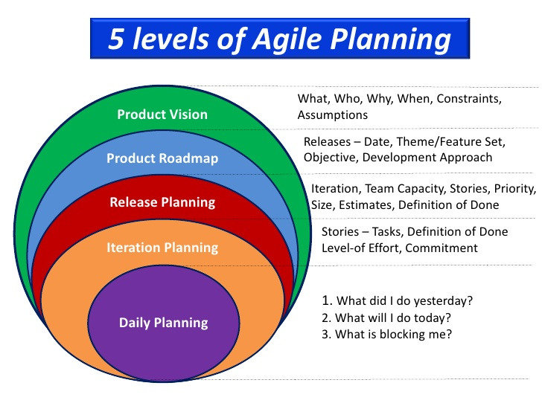

Image source: Evon Technologies

1. **The Concept stage is where the project is envisioned.**

* What are you creating?
* Why are you creating it?
* Who is your target audience?

1. **During the Inception stage, the project requirements are discussed and decided.  Questions you should ask yourself include:**

* How many people will be working on this project?
* Where will you be working on the project? Where will you be meeting?
* What do you need to work on the project (For example, computers, internet access, access to subject matter experts)?
* What is the project time-frame?

1. **This is the construction stage. During this step, the project is created.**

* The project is continuously updated following weekly/daily meetings.
* Apply feedback as soon as possible to ensure the best end-result.

1. During the Release stage, the final product is tested to ensure quality work.

* The project enters the production phase to prepare for release.

1. The product is updated during the Production stage based on the testing feedback.

* Documentation is updated to reflect changes in the newer versions.

# The SCRUM Method:

The **SCRUM method** is an example of **Agile Project Management**, defined as a framework that the **SCRUM team** (comprised of a Product Owner, Development Team and a SCRUM Master) can utilize. By participating in the **5 SCRUM events**, a SCRUM team can address complex and adaptive problems, while productively delivering products or services of value. A benefit of applying the SCRUM method is that the resulting Scrum Team becomes highly flexible, adaptive and collaborative in working with other teams (within the same organization) to develop, release, operate and sustain work and work products.

For each SCRUM event/Sprint Step the same equipment and supplies are required:

* A product backlog to identify Sprint Goals and break down work into manageable chunks
* A meeting room for discussion purposes
* Laptops, Internet (for file sharing) and a Platform (software) for publishing the Project

**The following table organizes the 5 SCRUM events, the responsibilities of each SCRUM team member, and provides examples to illustrate how each SCRUM event is utilized in the context of managing the *How-To Handbook for Tech Comm’ers project*:**

| SCRUM event and Team Responsibilities: | Example in Relevant Context: |
| --- | --- |
| 1. **Sprint Planning**   **Scrum Master:**  •Guides the Sprint Planning Meeting  **Development Team:**  •Plan and discuss the work involved in each Sprint increment to reach “Done status” or Sprint Goal | * Working with the How-To Handbook assignment outline designed by Product Owner * Discussing content to be included with your group members * Identify the Who, What When, Why, Constraints and Assumptions |
| 1. **Daily SCRUM meeting**   **Scrum Master:**  •Guides the daily meeting for 15 minutes  **Development Team:**  •Plans workflow for the next 24 hours  •Improve communications, identify obstacles to development and remove them, highlight quick decision-making and improve everyone’s knowledge. | * Regular group meetings to discuss “what did I do yesterday?” * Answer “what did I do today?” * Answer “what is blocking me?” |
| 1. **Development Work**   **Scrum Master:**  •Guides daily SCRUM meetings  **Development Team:**  •Executes the tasks and activities to create a project's product  **Product Owner:**  •Reviews, fine-tunes, and regularly updates the Product Backlog | * Delegate and distribute even workload for all group members * Get the work completed * Work together on the assignment using Google Docs * Edit and re-edit work on Microsoft Work for print publishing purposes |
| 1. **Sprint Review**   **Scrum Master:**   * Guides the Sprint Review that occurs once per Sprint   **Product Owner:**   * Discusses Product Backlog: target dates, delivery dates revised based on progress to date. * Review timeline, budget, potential capabilities and marketplace for next Sprint * Revision of how the marketplace or use of product might have changed   **Development Team:**   * Discusses Sprint successes, problems encountered and solutions. * Showcases work completed and answers questions about the Increment | * Complete work for the Research Article and Presentation projected for Nov.9, 2017. Due date in TCN700 Course Assignments is updated * Revise previous work as format is changed to a 4-page Hand-out and Mini Presentation as of Nov.23, 2017. Over Zoom communications with Product Owner * Revise previous work as format is changed to a Chapter in a *How To Handbook for Tech Comm’ers* on Dec.10, 2017. * Adapt all previous versions of product deliverables to match current marketplace needs at Product Owner’s request |
| 1. **Sprint Retrospective**   **Scrum Master:**   * Guides the Sprint Retrospective meeting   **Development Team:**   * Re-evaluate and create a plan for improvements to be implemented during the next Sprint | * Discuss how the last Sprint (increment of project completion) went regarding people, relationships, process and tools * At the end of the project, identify and order major items and acknowledge successes and failures to be improved upon for next How-To Handbook entry * Plan for improvements in workflow (development processes and practices) for any documentation project |

# Next Steps (Supplementary Reading about Agile Project Management):

Alexander, Moira. “Agile project management: A beginner's guide.” CIO, CIO, 12 Jan. 2017, [www.cio.com/article/3156998/agile-development/agile-project-management-a-beginners-guide.html](http://www.cio.com/article/3156998/agile-development/agile-project-management-a-beginners-guide.html).

Schwaber, Ken, and Jeff Sutherland. “The Scrum Guide.” The Scrum Guide, Scrum Alliance, 2016, www.scrumalliance.org/why-scrum/scrum-guide