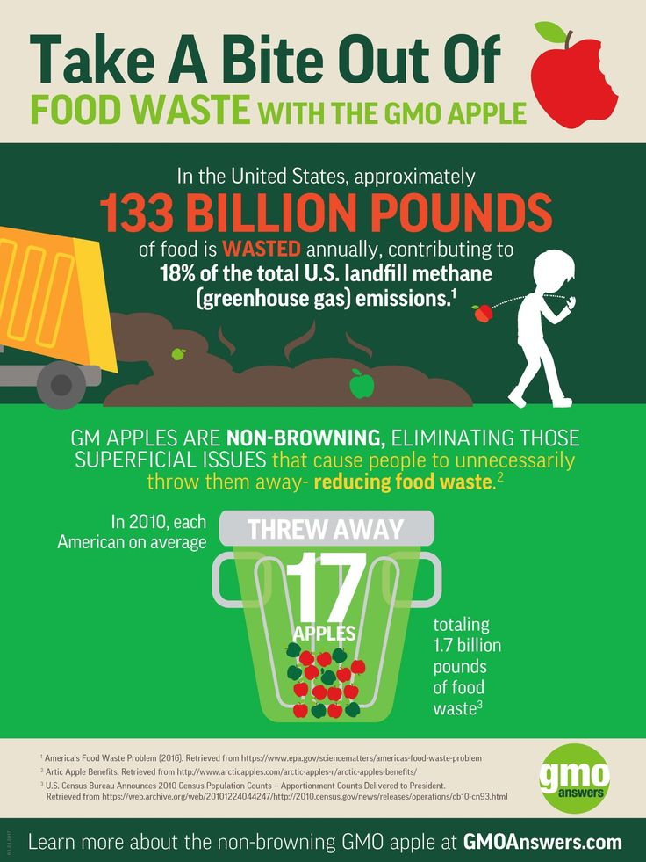

Anthia Pun- awpun@myseneca.ca| TCN 705-White Paper Assignment Final, Biotechnology | April 8, 2019.

Genetically Modified Food: Friend Rather Than Foe

**Table of Contents**

**1. Introduction 1**

**1.1 Target Audience 1**

**1.2 Objectives 1**

**1.3 GMO Food is a Friend to Humans and the Environment 2  
1.4 GMO Food Modified to Last Longer 2  
1.5 GMO Food Enhanced for Flavour 2  
1.6 GMO Food Enhanced for Optimal Human Health 3  
1.7 Safe and Effective Environmental Practices in the Cultivation of GMO Food 3**

**2. Recommendations and conclusions about gmo food 4**

**2.1 Bt Corn and its Effects on Monarch Butterfly Larvae 4**

**2.2 GMO Food Safe for Human Consumption 5**

**3. High Level Solution details: sustainable farming practices used for gmo crops 6  
3.1 Crops with the Bt (Bacillus Thuringiensis) Trait 6**

**3.2 Herbicide Tolerant (HT) crops and Conservation Tillage 7  
3.3 Nitrogen Use Efficient (NUE) GM Crops 9**

**4. Business bENEFITS 10**

**4.1 GMO Food and its Value for Money (Farmers) 10**

**4.2 GMO Food and its Value for Money (Consumers) 11**

**4.3 GM Food and its Adherance to International Safety Standards 12  
4.4 GMO Food and its Adherence to National Safety Standards 12**

**5. Summary 14**

**5.1 How GMO Food Benefits the Consumer 14**

**5.2 How GMO Food Benefits the American Farmer 15**

**5.3 How GMO Food Benefits the Environment 15**

**6. Works Cited 17**

1. Introduction

Despite controversy that argues otherwise, GMO (genetically modified) food is enhanced to offer consumers the benefits of nutrient-enriched products that last longer, taste better and are safer for consumption. Cultivated with safe practices that are environmentally conscious, consumers have little to worry about. With an abundance of GMO food products available in American grocery stores and low costs maintained by abundancy, the average consumer is encouraged to use their purchasing power to support local farmers and America’s GMO industry.

1.1 Target Audience:

U.S. consumers that go grocery shopping on a weekly basis, but cannot afford to buy organic food that is considered healthier for consumption than GMO (genetically modified) food. These individuals should be better informed of the quality standards that genetically modified food upholds, even though comparatively in price, it is cheaper than organic food options. U.S. consumers have an opportunity to be better educated about the environmentally-friendly cultivation practices behind their GMO food and be re-assured that it is safe for consumption. Understanding that GMO food is still healthy for consumption and grown with environmental sustainability in mind, will convince U.S. consumers to keep shopping and supporting the GMO food industry, instead of switching to “healthier” and more expensive food options like organic food.

1.2 Objectives:

The objectives of this white paper are to primarily address the environmental benefits of harvesting GMO food to re-affirm U.S. consumers’ decision to purchase and consume GMO food. In addition, laboratory experimental examples of how GMO food negatively impacted the health of a different species will be addressed. As well, re-assurance will be provided for U.S. consumers that GMO food undergoes much rigorous testing before it is available for purchase to the public, and adheres to strict U.S. and global food practice standards. Also explored is the health benefits of GMO food for the human body and its comparisons to organic food.

1.3 GMO Food is a Friend to Humans and the Environment:

GMO (Genetically modified) food can last longer, remain fresher, be immune to certain viruses and pests, yield a distinct texture and flavour and/or contain enriched amounts of vitamins and protein. The extended shelf-life, healthiness of the crops during cultivation and health benefits all make GMO food a popular choice for U.S. consumers. However, the most important aspect of GMO food is the sustainable farming practices behind such harvests. GMO food crops and cultivation practices are deemed environmentally friendly and help to sustain the surrounding ecosystem. The importance of sustainable GMO food practices decreases the chances of food shortages, regarding crops grown in the United States. U.S. consumers should buy GMO food to support the cultivation of healthy food available at lower prices.

1.4 GMO Food Modified to Last Longer:

Scientists have created GMO tomatoes that last three times as long as normal tomatoes, with a shelf-life of 45 days before beginning to show signs of wilting (Devlin). By eliminating the effects of particular genes, scientists can interrupt the ripening process of the tomato fruit (Devlin). As a result, GMO tomatoes mature at the typical rate with the same yields as normal tomatoes, but stay firmer for longer (Devlin). The researchers from the National Institute of Plant Genomic Research in New Delhi, India, estimate that 40% of the world’s harvested food is wasted because it ripens too quickly (Devlin). GMO tomatoes are just one example of how GMO food benefits the consumer by lasting longer, preventing food waste and re-purchase of product in shorter amounts of time. GMO food that lasts longer has a higher percentage of being consumed by the purchaser, leading to less food waste that ends up in a land fill-an environmentally friendly benefit. Who doesn’t want to save money on food, have it last longer in the fridge and throw less of it away as litter that negatively impacts the environment?

1.5 GMO Food Enhanced for Flavour:

Another trend to take note of in the global Agricultural and GMO industries is the invention of food enhanced for flavour. Why is flavourful food important? Simply because it appeals to certain U.S. consumers. Nobody likes the concept of bland food. For example, Chinese scientists have been experimenting with a local Chinese breed of cattle named “Qinchuan,” provided with an extra gene to increase the amount of fat in their muscles (Gray). Specifically, the creation of adiposcyte fatty acid binding protein is encouraged to increase the fat between the test cattle’s muscles (Gray). The result is richly marbled cuts of beef-tender, juicy and flavourful as competition for Japan’s famous wagyu beef (Gray). Marbling of fat in beef products is a clear visual indication of flavour (Gray). U.S. consumers can look forward to such delicious products soon.

1.6 GMO Food Enhanced for Optimal Human Health:

The biofortified example of Golden Rice, is proof that GMO food is developed to help compensate for human health deficiencies, like a poor diet. For the U.S. demographic that consumes a lot of rice, Golden Rice is a good option, specifically engineered to produce high levels of B-carotene that is converted into Vitamin A (Hefferon). Golden Rice is the first example of biofortification used to combat malnutrition specifically a Vitamin A deficiency in rice-consuming populations (Hefferon). In addition, scientists can tweak the genetic make-up of other kinds of rice to help increase iron and folate levels in a human consumer (Hefferon). GMO food is enhanced to provide healthier benefits of consumption for humans and to address existing issues in the imbalanced, typical American diet of fast food.

1.7 Safe and Effective Environmental Practices in the Cultivation of GMO Food:

U.S. Farmers in the Agricultural industry are utilizing smarter and more effective practices in the cultivation of GMO food, all of which are safe practices for maintaining the health of the environment. Under GMO crops is the example of Bt crops (Bacillus thuringiensis) that are modified to resist the effects of insect infestations (e.g. crop damage) (GMO Answers). As a result, farmers can apply fewer pesticide treatments to Bt crops while maintaining the health of the surrounding environment. In addition, HT (Herbicide tolerant) crops enable farmers to practice conservation tillage, which leads to healthier farming soil, higher crop yields and better water retention in the field soil (GMO Answers). Perhaps the most interesting sustainable farming practice in the cultivation of GMO food is found in the example of NUE GM (Nitrogen Use Efficient Genetically Modified) crops. Nitrogen fertilizer is a necessity for growing healthy and abundant crops, but NUE GM crops can absorb higher amounts of nitrogen fertilizer, allowing farmers to purchase and apply less fertilizer; the result is less fertilizer run-off into surrounding water sources-a lessened impact on overall pollution (GMO Answers). Bt crops, HT crops and NUE GM crops are just a few examples of how GMO Food is harvested using environmentally-friendly solutions.

# 2. Recommendations and Conclusions about GMO Food

Processes that genetically modify food and food crops have been used wisely and responsibly by the Agricultural and GMO industries, with utmost focus on quality food products that last longer, taste better, improve your health and grow with ease during cultivation. GMO food is invented, rigorously tested and must meet multiple health standards before being deemed safe for human consumption. With years of research and funding funneled into the creation of food that is modified to benefit the human body, one can trust the GMO and Agricultural industries to abide by quality food product standards with the aim to preserve and improve upon human health.

2.1 Bt Corn and its Effects on Monarch Butterfly Larvae:

"Bt", or bacillus thuringiensis, is **bacterium**that is**found naturally in soil**and works as an insecticide (Government of Canada). Scientists developed a gene in corn that triggers the production of the Bt protein, hence the invention of Bt Corn-insect resistant corn (Government of Canada). Insecticides like Bt that are produced within a plant are more effective than pesticides that are sprayed on top of a plant (Government of Canada). To determine the effectiveness and safety of Bt Corn, researchers at Cornell University decided to feed milkweed leaves that had been dusted with Bt Corn pollen to a few monarch caterpillar test subjects (Government of Canada). In doing so, the researchers could simulate a situation where wind-born Bt Corn pollen could settle onto the leaves of milkweed plants, which is all that monarch butterfly larvae consume (Government of Canada). Research provided results where the test subject monarch butterfly larvae ended up progressively consuming less of the milkweed leaves, reached maturity at a slower rate and suffered higher mortality than the larvae that did not consume milkweed leaves containing Bt Corn pollen (Government of Canada).

The outside perspective on this case study is that the laboratory conditions for testing how monarch butterfly larvae responded to Bt Corn pollen consumption was too limiting. For example, there were higher amounts of Bt Corn pollen on the milkweed leaves in the lab than normally found in a field (Government of Canada). Another problem in the laboratory simulation is found in where the caterpillar larvae were only forced to eat the milkweed leaves covered in Bt Corn pollen (Government of Canada). In reality, caterpillar larvae have a choice to eat any milkweed leaf found in a field, and not all leaves would be covered in Bt Corn pollen. Other scientists decided to conduct further research into the effects of Bt Corn pollen consumption on monarch caterpillar larvae, and eventually concluded that there were no significant health risks to this species (Government of Canada). One of the studies concluded that “the risks to monarch butterflies from Bt Corn pollen is less than 1/100 of 1%” (Government of Canada). The health risks of Bt Corn consumption to humans is even less than 1/100 of 1%, and therefore, nothing worth being concerned about.

2.2 GMO Food Safe for Human Consumption:

The genetic modification of food (biotechnology) is not a new concept, and there are very few differences between GMO food and Non-GMO food. All living things contain DNA that scientists can move from one organism into another; the result is an enhanced organism containing a specific, desired trait (American RadioWorks). A report published on June 7, 2016. by the National Academy of Sciences claims that there are no potentially negative health effects in consuming GMO crops; therefore, GMO crops are as safe to eat as non-GMO products (Kubitz). According to the report, there is no published evidence to prove that the consumption of GMO food causes higher U.S. rates of obesity or type 2 diabetes (Kubitz). Also, there are no links between the consumption of GMO Food and an increase in food allergies within humans (Kubitz). Last, there is no conclusive proof that eating genetically modified food will cause a human to develop autism (Kubitz). GMO food is safe for consumption and remains accessible and affordable to U.S. consumers.

# 3. High Level Solution Details: Sustainable Farming Practices used for GMO Crops

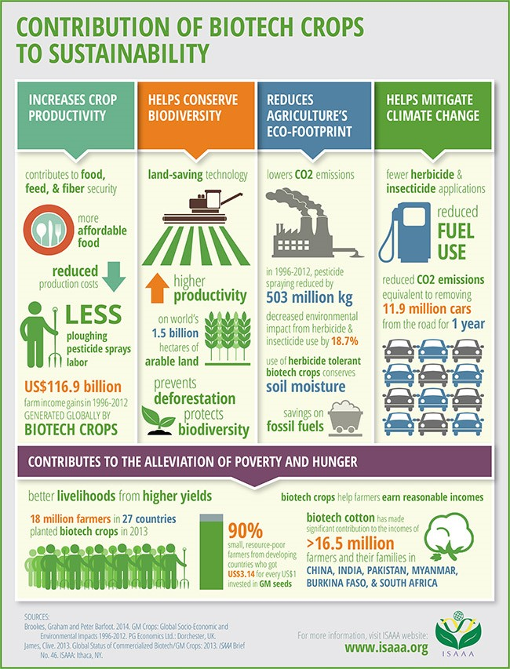

Argument in favour of purchasing and consuming GMO food products is best advertised by explaining the sustainable agricultural practices that farmers utilize to maximize production and minimize impact on the surrounding environment. Such practices allow for abundant GM food crop yields to meet the demands of U.S. consumers, while ensuring the same farm land can be re-used for harvesting techniques that aim to minimize the use of pollutants. To understand where GMO food comes from, and the care and quality involved in its growing practices, enables consumers to feel good about what they eat.

Figure 3.0: How GMO Crops benefit the environment.

3.1 Crops with the Bt (Bacillus Thuringiensis) Trait:

Bt (Bacillus thuringiensis) traits applied to food crops works by targeting specific insect species and killing them, allowing for fewer pesticide applications. For example, Bt Corn has a gene that encodes a protein toxic to the European corn borer- an insect that would otherwise destroy corn stems through consumption (Hall). In general, Bt has two types of toxins called cytolysins and crystal delta-endotoxins (Hall). The first type of toxin primarily targets beetles and flies, while the second type of toxin targets moths and butterflies (Hall). Bt crops produce toxic proteins that only affect the gut of certain target pests; the Bt trait is harmless to humans and most non-target insects (gmoanswers). In this way, Bt crops can be harvested safely, while maintaining the biodiversity of the farming environment. Insect resistant, Bt crops reach full maturity and are harvested in larger quantities. With larger quantities of Bt-insect resistant crops- consumers can enjoy GMO food for lower prices and not have to worry about food shortages. Also, the fact that less pesticide chemicals have been used in the cultivation of Bt crops contributes to its lower selling prices and healthiness for human consumption.

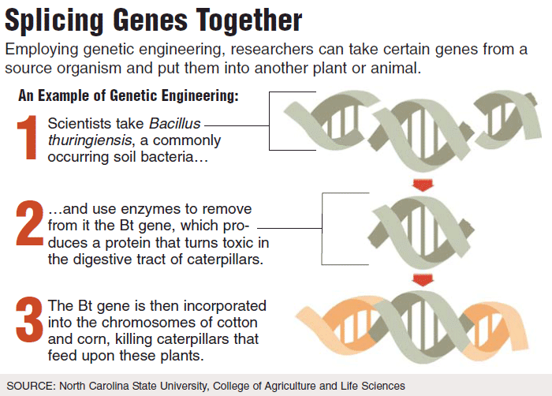

**Figure 3.1:** The process of incorporating Bt trait into crops to provide insect-repellant qualities.  
  
  
3.2 Herbicide Tolerant (HT) Crops and Conservation Tillage:  
 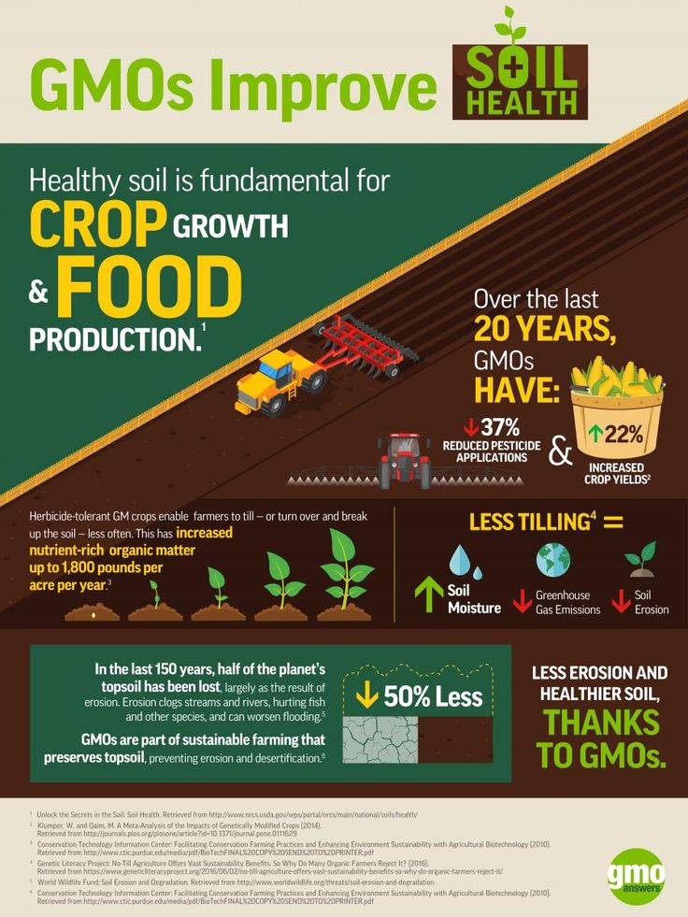  
**Figure 3.2:** HT crops and conservation tillage.  
  
  
  
 Herbicide Tolerant (HT) crops and the farming practice of conservation tillage go hand-in-hand. Originally, farmers dealt with weed control in their farm fields by a process called tillage. Tillage refers to the process of using farming equipment to turn over the top layer of soil to uproot weeds-weeds that fight for nutrients and growth space and choke-off the roots of crops (gmoanswers). Tillage is not an example of a sustainable farming practice because it leads to field soil erosion, chemical run-off and releases carbon dioxide into the atmosphere through the excessive use of farming equipment (gmoanswers). Tillage ends up causing more harm to the environment and its only benefit is effective weed removal. Farmers began planting Herbicide Tolerant (HT) crops and using the sustainable farming practice of conservation tillage to preserve the soil’s health, while getting rid of weeds in the farm fields. First, the farmers spray the weeds in the field with Herbicide (gmoanswers). The weeds die and are left as organic matter that mixes in with the left-over residue of past crops to create a mulch layer that protects the soil from erosion (gmoanswers). Then the HT (Herbicide Tolerant) crops are planted directly into the leftover organic matter, without any soil turnover (gmoanswers). The result is healthy soil that retains water quite well and reduced chemical runoff into surrounding water sources; the farm fields are well-maintained and are sustained for further crop cultivation (gmoanswers). The partnership of HT crops and conservation tillage helps to maintain the farm’s environment while minimizing the use or spread of pollutants like chemical runoff and carbon dioxide from farm equipment, which leads to the creation of more greenhouse gases (gmoanswers). U.S. consumers can feel good that their GMO food, most likely some form of HT crop, was cultivated in an environmentally friend and sustainable manner and contains less amounts of chemicals than crops cultivated using other farming methods.  
  
  
  
3.3 NUE (Nitrogen Use Efficient) GM Crops:  
  
 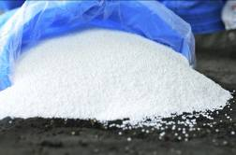 Figure 3.3: Nitrogen Fertilizer

Nitrogen Fertilizer is one of the primary macronutrients used by most farmers to ensure their crops grow healthy and plentiful. Nitrogen Fertilizer is important for plant grow and development, helping a plant to produce nucleic acids and proteins (ISAAA). Plant researchers have been working to develop [Nitrogen Use Efficient (NUE) GM crops](https://www.isaaa.org/resources/publications/pocketk/46/default.asp), in order to help plants more efficiently absorb fertilizers, enabling farmers to purchase and apply less fertilizer, and thereby reducing nitrogen pollution in our waters. If the genetically modified crops can absorb larger amounts of nitrogen fertilizer and thrive, less of the fertilizer will leak into the soil or surrounding water sources; the result is less pollution. NUE GM crops are genetically modified to absorb larger amounts of nitrogen fertilizer, allowing for larger crop yields to be produced in areas where Nitrogen Fertilizer is difficult to obtain(gmoanswers). CropLife International reports that research trials indicated that crops with the NUE trait had 15 % larger yields than crops without this trait. NUE GM corn, wheat, rice and canola (for oil) crops is already available for American farmers to grow from, as there is always high consumer demand for these types of crops (gmoanswers). This is good news for U.S. consumers because such popular food sources are stable and grow healthier with nitrogen fertilizer that is applied; crop yields will remain steady or increase, and prices will remain low.

4. Business Benefits  
  
 Thanks to GMOs, farmers can grow more food with a higher yield and spend less money on crop protection, which benefits us all as food consumers. The perks of growing GMO crops extend to fewer applications of pesticides to kill target insects, meaning less chemical used in the food that U.S. consumers eat on a regular basis. Also, with HT (Herbicide Tolerant) crops and conservation tillage, farmers can apply fewer herbicide treatments to their crops; this allows for healthier and less-chemically covered food for U.S. consumers. Last, with the use of NUE (Nitrogen Use Efficient) GM crops, farmers can meet the high consumer demand for food such as rice, corn, canola oil and wheat that will be produced in higher yields. U.S. consumers do not have to worry about such staple food shortages and can look forward to lower prices as yields for these crops will be high when NUE is utilized in crop cultivation. Perhaps the most important aspect of GMO food though is the reassurance of its safety for regular human consumption. With testimonials from the world’s leading agricultural and food administration boards proving that GMO food passes numerous time-consuming tests, consumers can feel more comfortable purchasing GMO food that is relatively affordable, but deemed healthy as well.  
  
  
4.1 GMO Food and its Value for Money (Farmers):  
  
 The United States is considered the largest GM farming area in the world. Approximately 40% of farming land in the United States is used to cultivate GMO crops (cban). American farmers have unlimited resources at their disposal including access to irrigation, fertilizers pesticides and herbicides to ensure the success of their expensive GMO crops (cban). American farmers will pay a higher price and buy GMO seeds from a supplier like Monsanto (the world’s largest GMO seed producer and supplier since 2005), trusting that the research and quality put into developing such GMO crop seeds, will pay off in more abundant crop yields (cban). The USDA (United States Department of Agriculture) studies also found that US farmers adopt GM crops to decrease pesticide input costs, save management time, and make other farm practices easier to complete (cban).   
  
 To begin, U.S. farmers plant Bt (Bacillus thuringiensis) crops that are genetically modified to resist insect attacks. This leads to a decreased use in chemical pesticides, allowing farmers to save money on the purchase and application of such chemicals (Bio). In addition, U.S. farmers plant HT (Herbicide Tolerant) crops that are genetically modified to tolerate high amounts of herbicide chemical and kill-off surrounding weeds. The HT crops are harvested, and their residual crop leftovers are used as a protective mulch layer that covers the farming field soil to prevent it from further erosion (gmoanswers). The result is healthier farming soil that retains water and keeps its moisture (gmoanswers). Further benefits of planting HT crops are that they allow for fewer applications of herbicide chemical; this allows farmers to save money on purchasing herbicide chemical and to save time on applying the chemical numerous times to fight-off weeds. Also, with better soil moisture retention because of HT crops, farmers can save time and money on constantly watering their crops (Bio). Furthermore, Bt and HT crops result in fewer applications of pesticide and herbicide chemicals by farmers, meaning the farming equipment that is used to apply such chemicals is used less frequently; the result is less carbon dioxide emitted from farming equipment and overall, less pollution, which benefits the environment of the farm land and its surrounding ecosystem. Perhaps farmers care more about using their farming equipment less often to apply pesticides and herbicides, meaning less money spent on fuel and more profit in the farmers’ pockets (Bio). The Biotechnology Innovation Organization quotes that as of 2011, the United States witnessed a net economic benefit at the farm level of $19.8 billion-$133 per hectare of GMO farm land (Bio). In addition, the total farm income benefit as of 2011 for American farmers is due in large part (49%) to the yield gains of GMO crops that allowed for lower pest and weed damage (Bio). American farmers are benefitting in the end from larger crop yields, reduced pesticide and herbicide applications and reduced costs spent on fueling farm equipment, which all results in more money saved and made from planting GMO crops.   
  
  
  
4.2 GMO Food and its Value for Money (Consumers):  
  
  
 Consumers are fortunate to have the opportunity to purchase food at lower costs in grocery stores simply because of biotechnology and its advancements. As previously mentioned, Bt and HT crops allow for decreased use in herbicides and pesticides, while allowing farmers to producer higher crop yields; with fewer applications of these chemicals, the surrounding environment’s health is better maintained and sustained. Between 1996 and 2012, it is recorded that the world’s farmers were able to produce an extra 122 million tons of soybeans, 237 million tons of corn and 6.6 million tons of canola, simply by planting genetically modified crop seeds (Stebbins). While farmers save money on chemical applications that would otherwise be applied frequently to ward-off insects and weeds, they also save money on fuel costs to operate the farming equipment necessary to apply such chemicals to the crops (Stebbins). The use of GMO crops saves farmers money and time in farming processes (reduced production costs), while resulting in abundant crop yields; consumers benefit from being able to purchase food at lower prices.   
  
  
 Switch over to the topic of NUE (Nitrogen Use Efficient) GM crops that absorb higher concentrations of nitrogen fertilizer. Nitrogen fertilizer is essential for plant growth and abundancy (gmo answers). By applying genetically modified nitrogen fertilizer to crops, farmers can create sustainable, healthy crop yields (gmo answers). Research trials show that the NUE trait applied to crops has improved overall crop yield by up to 15% over similar crops without the NUE trait (gmo answers). Farmers save costs in purchasing less of the nitrogen fertilizer that is modified to allow for fewer applications as well; in this way, they save a lot of money. With NUE GM crops, production costs are lowered, but crop yields are higher, which allows for lowered food costs in grocery stores and cheaper, more affordable food for U.S. consumers.

4.3 GM Food and its Adherence to International Safety Standards:  
  
  
 The cultivation and consumption of GM foods is strongly supported by The **American Medical Association**, The **World Health Organization** and the **National Academy of Sciences**, to name a few. The **American Medical Association** quotes that “foods derived from GM crops have been consumed by hundreds of millions of people across the world for more than 15 years, with no reported ill effects (to human health), despite many of the consumers coming from the most litigious of countries, the USA.” From this quote is proof that there are no existing records of death by consumption of GMO food in the United States. Also, the **World Health Organization** states their approval of GMO food consumption, quoting that “GM foods currently available on the International market have passed safety assessments and are not likely to present risks for human health; no effects on human health have been shown because of the consumption of such foods by the general population in the countries where they have been approved.” With the United States being a country where GM food is approved of and grown, from a global perspective, the World Health Organization says that the consumption of genetically modified food is appropriate and poses no ill effects on human health. Last, the **National Academy of Sciences** supports the cultivation and consumption of GM food, quoting “the study committee found no substantiated evidence of a difference in risks to human health between current commercialized genetically engineered crops and conventionally bred crops, nor did it find conclusive cause-and-effect evidence of environmental problems from the GM crops.” The National Academy of Sciences is saying that there are very few, if any differences in health when consuming GM food and non-GM food and that both are good options for U.S. consumers. With so many powerful testimonials about the research put into studying the effects of GM food consumption and the results saying GM food is safe to eat on a regular basis, U.S. consumers can be assured that the affordable GM food they purchase is of high quality.  
  
  
4.4 GMO Food and its Adherence to National Safety Standards:  
  
 From a national level, only a few crops have passed the rigorous testing of safety and health standards to be genetically modified and become more insect resistant (IR), herbicide tolerant (HT), drought tolerant (DT) and virus resistant (VR).  
  
**Figure 4.4:** Currently grown GMO crops in the U.S. and the traits for which they have been modified. **IR**= insect resistant, **HT**=herbicide tolerant, **DT**=drought tolerant, **VR**= virus resistant.  
  
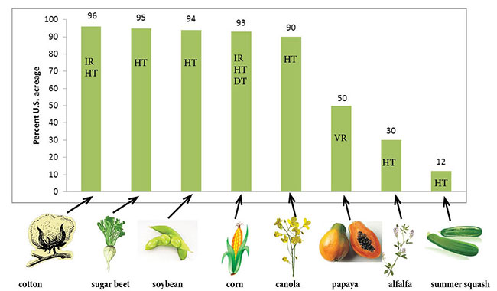

Three U.S. government entities have the authority to regulate GM crops: The United States Department of Agriculture (USDA), the Environmental Protection Agency (EPA) and the Food and Drug Administration (FDA).   
  
  
 The USDA approves the field release of most GMO plants (CSU). Approval is required for crop developers to start supplying GMO seeds to farmers for cultivation of crops.

 The EPA regulates the use of pesticides in the cultivation of GMO crops (CSU). Ensuring that pesticides do not cause more harm to the surrounding environment (plants and insect and animal species) is of utmost importance.

 The FDA regulates GMO crops destined for food, feed or pharmaceuticals (CSU). GMO crops need to be well-tested for safe animal and human consumption before being available to the public for purchase and use.  
  
  
All 3 federal agencies extensively review the submitted information by biotechnology companies that genetically modify seeds like Monsanto, and conduct further investigations about the nature and stability of the modified crop, its transgene and protein product, its effects on non-target organisms planted in the same field, the composition of the food product and the potential for allergic reactions from consumers (CSU). Then, if the federal agencies are satisfied and have enough proof that the modified crop does not pose threats to the environment and is safe for food and feed consumption, the crop is determined to have nonregulated status (CSU). The next step is approval for commercialization of the GMO crop (CSU). Understanding that GMO crops are tested by three different, but collaborative federal agencies and are investigated for safe cultivation practices and consumption by animals (feed) and by humans (food) means that the average American consumer can rest easy and know that their food meets all the required national health and safety standards. People should be informed of where their food comes from and whether it means the high-quality standards reinforced by the American government to protect the health of its citizens.  
  
  
5. Summary  
  
5.1 How GMO Food Benefits the U.S. Consumer:  
  
 Overall, GMO Food is worth purchasing and consuming because it can last longer, remain fresher and contain enriched amounts of vitamins and proteins that benefit human health. Sustainable farming practices like the utilization of Bt crops (Bacillus thuringiensis), HT (Herbicide Tolerant) crops and NUE (Nitrogen Use Efficient) GM crops enables farmers to surpass the consumer demand for staple food items like rice, wheat, canola oil and corn to keep food prices low and well-stocked year-round. Perhaps the most impressive feature of the sustainable GMO food cultivation practices is how environmentally friendly they are, allowing for conservation tillage, the re-use of the same farm land and decreased amounts of carbon dioxide as farming equipment is used less frequently to apply chemical herbicides, pesticides and fertilizer. With the use of genetically enhanced nitrogen fertilizer, GMO crops can absorb more nutrients, allowing farmers to apply fewer applications of fertilizer; in this way, fertilizer run-off into surrounding water sources is contained and minimized. With so many benefits for bettering human health and the environment, U.S. consumers should have no problem supporting the GMO and Agricultural industries by buying GMO food products.  
  
  
5.2 How GMO Food Benefits American Farmers:  
  
 GMO crops in the forms of Bt, HT and NUE GM crops are an American farmer’s best bet for profit. Bt ((Bacillus thuringiensis) crops target the guts of certain insect species like moths, butterflies, flies and beetles that would otherwise cause damage resulting in a loss of crops and farmers’ profits. HT (Herbicide Tolerant) crops allow farmers to apply less herbicide to control weeds in the farming fields, while encouraging the farming practice of conservation tillage to preserve soil health and increase water retention. As a result, farmers save more money by purchasing less herbicide and fuel to operate farming equipment necessary for such purposes. Also, farmers can save time and money on less irrigation as conservation tillage allows for better water retention in the farm soil. Last, the use of NUE (Nitrogen Use Efficient) GM crops allows farmers to purchase less and apply less fertilizer, which means more money saved in their pockets. Bt, HT and NUE GM crops are recorded as resulting in larger crop yields on average than non-GMO crops that are planted by American farmers. By using the advancements in biotechnology, farmers can ensure success and a return in value for the money they invest in good quality, sustainable and hearty crops.  
  
5.3 How GMO Food Benefits the Environment:  
  
 GMO crops are rigorously tested to ensure they do not harm the well-being of the environment while being cultivated. Bt crops contain genetic proteins that only harm certain insect species that would otherwise cause devastation. Bt crops are safe for human consumption and do not affect non-target species. Also, Bt, HT and NUE GM crops allow farmers to apply less chemicals, meaning less pesticide use, herbicide use, and fertilizer use that would otherwise contaminate surrounding water sources and the soil. In addition, because such chemicals are applied less frequently, there is less need to fuel-up and use farming equipment that emits carbon dioxide, which contributes to the greenhouse gases in the Earth’s atmosphere; GMO crops are cultivated in ways that minimize pollution. Last, the biodiversity of the environment surrounding American farm fields is of utmost importance and must be preserved. When American farmers plant HT crops, they can practice conservation tillage to preserve the health of the farming field soil, enabling the same plot of land to be re-used for farming purposes; re-use of farm land preserves the surrounding environment.  
  
 Sustainable farming practices in the cultivation of GMO food, food that Americans consume daily is important in ensuring a steady supply of food is readily available in the near future and for years to come. With so much money poured into the advancement of creating genetically modified seeds that lead to good quality, nutritious food crops, Americans have many reasons to buy food as it is, and appreciate the low prices of GMO food products, as compared to organic.

6. Works Cited  
  
American Public Media. “GM CROPS: THE ARGUMENTS PRO AND CON.” *The Arguments Pro and Con | Engineering Crops in a Needy World*, American RadioWorks, 5 Oct. 2016, americanradioworks.publicradio.org/features/gmos_india/pro_con.html.  
  
Andrews, Ryan. “Splicing Genes Together.” *All About Genetically Modified Foods*, Precision Nutrition, 28 July 2017, www.precisionnutrition.com/all-about-gm-foods.  
  
Batra, Karen. “GM Crops Increase Farmer Profits and Environmental Sustainability.” *GM Crops Increase Farmer Profits and Environmental Sustainability*, Bio-Biotechnology Innovation Organization, 14 June 2017, www.bio.org/media/press-release/gm-crops-increase-farmer-profits-and-environmental-sustainability.  
  
Byrne, P. “Genetically Modified (GM) Crops: Techniques and Applications - 0.710.” *Genetically Modified (GM) Crops: Techniques and Applications – 0.710*, Colorado State University , 5 Aug. 2014, extension.colostate.edu/topic-areas/agriculture/genetically-modified-gm-crops-techniques-and-applications-0-710/.  
  
Canadian Food Inspection Agency. “Biotechnology Products: Plants That Tolerate Herbicides.”*Canadian Food Inspection Agency-Plant Health and Biosecurity Directorate*, Government of Canada, 19 Aug. 2014, www.inspection.gc.ca/plants/plants-with-novel-traits/general-public/herbicide-tolerant-plants/eng/1338136535331/1338136720078.

Canadian Food Inspection Agency. “Do Bt Crops Affect Monarch Butterflies?” *Do Bt Crops Affect Monarch Butterflies?*, Government of Canada,Canadian Food Inspection Agency,Plant Health and Biosecurity Directorate, 3 July 2014, www.inspection.gc.ca/plants/plants-with-novel-traits/general-public/monarch-butterflies/eng/1338140112942/1338140224895.  
  
Cban. “Are GM Crops Better for You?” *Are GM Crops Better for You?*, gmoinquiry.ca/wp-content/uploads/2015/11/Are-GM-crops-better-for-farmers-E-web-singles.pdf.

Devlin, Kate. “Scientists Create GM Tomatoes 'Which Stay Fresh for a Month Longer than Usual'.” *Scientists Create GM Tomatoes 'Which Stay Fresh for a Month Longer than Usual'*, The Telegraph, 2 Feb. 2010, www.telegraph.co.uk/news/science/7128622/Scientists-create-GM-tomatoes-which-stay-fresh-for-a-month-longer-than-usual.html.  
  
FAS. “U.S. Regulation of Genetically Modified Crops.” *Case Studies in Agricultural Biosecurity*, FAS-Federation of American Scientists, 27 Jan. 2011, fas.org/biosecurity/education/dualuse-agriculture/2.-agricultural-biotechnology/us-regulation-of-genetically-engineered-crops.html.  
  
Gewin, Virginia. “Genetically Modified Corn— Environmental Benefits and Risks.” *PLOS Biology*, Public Library of Science, 13 Oct. 2013, journals.plos.org/plosbiology/article?id=10.1371%2Fjournal.pbio.0000008.  
  
GMOAnswers. “Get To Know GMOs Month: Sustainable Farming Practices You Didn't Know Are Used with GMO Crops.” *GMO Answers*, Counsel for Biotechnology Information, 9 Oct. 2015, gmoanswers.com/studies/5-sustainable-farming-practices-GMO.

GMO Answers. “Sustainable Farming Practices of GMO Crops.” *. “Get To Know GMOs Month: Sustainable Farming Practices You Didn't Know Are Used with GMO Crops.,”* GMO Answers, Counsel for Biotechnology Information, 9 Oct. 2015, gmoanswers.com/information-and-resources/infographics-and-downloadables/115.  
  
Gray, Richard. “Cows Genetically Modified to Improve Flavour.” *The Telegraph*, Telegraph Media Group, 26 Aug. 2012, www.telegraph.co.uk/news/science/science-news/9498987/Cows-genetically-modified-to-improve-flavour.html.  
  
Hall, Hardy. “BT CORN: IS IT WORTH THE RISK?” *BT CORN: IS IT WORTH THE RISK?*, SCQ-The Science Creative Quarterly, 5 Sept. 2006, www.scq.ubc.ca/bt-corn-is-it-worth-the-risk/.  
  
Hefferon, Kathleen L. “Home - PMC - NCBI.” *Nutritionally Enhanced Food Crops; Progress and Perspectives*, U.S. National Library of Medicine, 16 Feb. 2015, www.ncbi.nlm.nih.gov/pmc/articles/PMC4346933/.  
  
ISAAA. “Pocket K No. 46: Nitrogen Use Efficient Biotech Crops.” *Nitrogen Use Efficient Biotech Crops - Pocket K | ISAAA.org*, International Service for the Acquisition of Agri-Biotech Applications, 13 Sept. 2016, www.isaaa.org/resources/publications/pocketk/46/default.asp.  
  
Kubitz, Laura. “Science Sent: GMOs Are Safe to Eat.” *Food Insight Your Nutrition and Food Safety Resource*, International Food Information Council Foundation, 31 May 2016, www.foodinsight.org/national-academy-sciences-gmo-crops-safe-eat.  
  
Monsanto. “Benefits of GMOs and Biotechnology.” *Unlocking Hidden Potential Biotechnology and GMOs*, Monsanto, 3 Mar. 2010, monsanto.com/innovations/biotech-gmos/.  
  
Stebbins, Michael. “You Can Thank GMOs for Lower Prices at the Grocery Store.” *You Can Thank GMOs for Lower Prices at the Grocery Store*, BIOtechNow, 18 Jan. 2017, www.biotech-now.org/food-and-agriculture/2016/05/you-can-thank-gmos-for-lower-prices-at-the-grocery-store.